Materials Science XRD Report: XRD2013-0287

To: | F Miani  L Lodya
S Manzini
S Potts

From: | G Mannsberger
Copy: | R Forbes
Approved By: | E du Plessis
First issued: | 18 November 2013
Updates:
Pages: | 5

XRD ANALYSIS OF IRON AND CARBON BALL MILLED SAMPLES

Background
Iron and carbon were ball milled for different periods of time . Powder X-ray diffraction analyses were done to determine the crystalline phase present.

Experimental
The sample name and the assigned sample codes are shown in Table 1.
Table 1 – Sample names
Sample Name | Sample background | Elements* | BD Number | MC Number
1. Fe₅C₉₅ BM 4H | Ball milled for 4 hours | Fe, Al, Si, Ag | BD0351 | MC-2013-0734-01
2. Fe₅C₉₅ BM 8H | Ball milled for 8 hours | Fe, Al, Si, Ag | BD0352 | MC-2013-0734-02
3. Fe₅C₉₅ BM 12H | Ball milled for 12 hours | Fe, Si, Ag | BD0353 | MC-2013-0734-03
4. Fe₅C₉₅ BM 16H | Ball milled for 16 hours | Fe, Al, Si, Ag | BD0354 | MC-2013-0734-04
5. Fe₅C₉₅ BM 24H | Ball milled for 24 hours | Fe, Al, Si, Ag | BD0355 | MC-2013-0734-05
6. Fe₅C₉₅ BM 40H | Ball milled for 40 hours | Fe, Al, Si, Ag | BD0356 | MC-2013-0734-06
* Elemental analyses from EDX

The samples were packed in PVC sample holders. A Bruker D8 Advance diffractometer was used to carry out the analyses. The data was collected at ambient temperature, atmospheric pressure and the instrument settings were as follows:
Tube voltage : 40 kV
Tube current : 40 mA
Source : Cobalt (wavelength 1.78897 Å)
Soller slit : 2.5 °
Fixed divergence slit : 0.6 mm
Anti-scatter slit : 2.5 °
Detector : Lynx Eye (2.947 °, 0.11 – 0.25V)
Scan from : 5 °2θ
Scan to : 135 °2θ
Scan mode : Locked Coupled
Step size : 0.014324898 °
Time per step : 0.1 seconds/step
Scan duration : 2 Hours
The crystalline phases present in the samples were identified using X’Pert HighScore Plus©.

XRD Results
The powder X-ray diffractograms of the ball milled samples are shown in Figure 1 and 2 below:
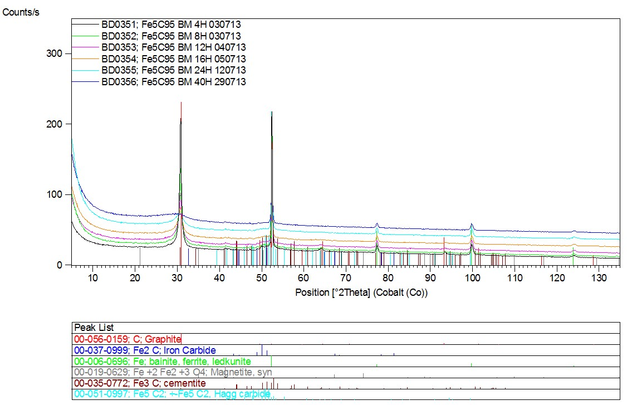
Figure 1 – X-ray diffractogram of ball milled samples
The sample contains
- Graphite – C
- Iron carbite – Fe₂C
- α – Iron – Fe
- Magnetite – Fe₃O₄
- χ - carbide - χ-Fe₅C₂
- Θ - Cementite- Θ - Fe₃C

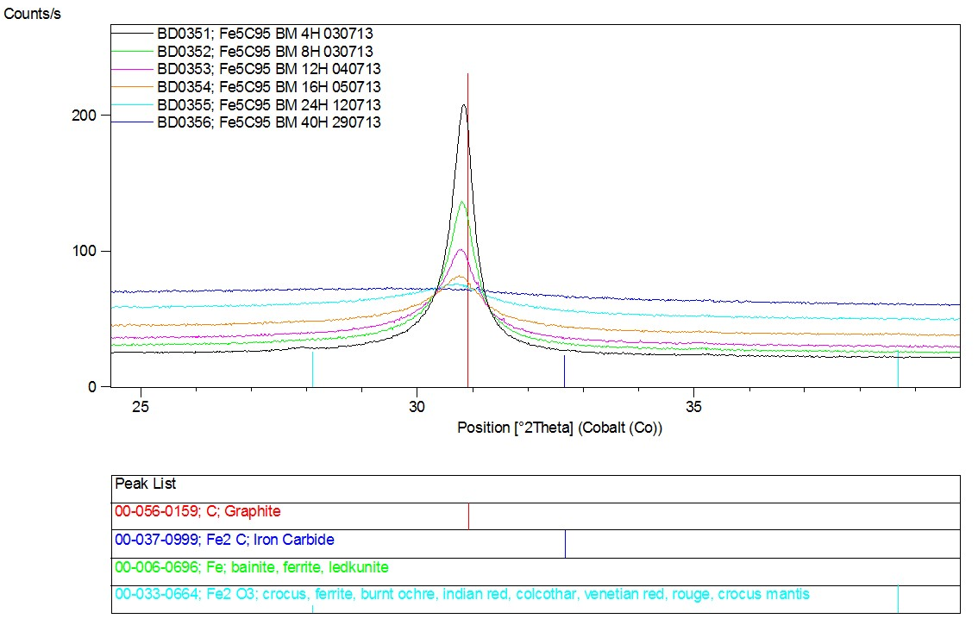
Figure 2 – X-ray diffractogram of the Carbon peak

The graphite contribution to the diffractogram was excluded from the Rietveld refinement. The Rietveld refinement results of the remaining crystalline phases are listed in the tables below:

Table 2 Relative abundance (%) of crystalline phases
Sample Name | α-Fe | Fe₂C | Fe₃O₄ | χ-Fe₅C₂ | θ-Fe₃C
1. Fe₅C₉₅ BM 4H | 68 | 4 | 1 | 10 | 18
2. Fe₅C₉₅ BM 8H | 73 | 3 | - | 15 | 10
3. Fe₅C₉₅ BM 12H | 63 | - | - | 26 | 10
4. Fe₅C₉₅ BM 16H | 63 | - | - | 29 | 8
5. Fe₅C₉₅ BM 24H | 67 | - | - | 24 | 9
6. Fe₅C₉₅ BM 40H | 62 | - | - | 18 | 20

Table 3 Average crystallite size (nm)
Sample Name | α-Fe | Fe₂C | Fe₃O₄ | χ-Fe₅C₂ | θ-Fe₃C
1. Fe₅C₉₅ BM 4H | 90(2) | 15(4) | - | 31(7) | 10(1)
2. Fe₅C₉₅ BM 8H | 95(3) | 15(6) | - | 23(5) | 10(3)
3. Fe₅C₉₅ BM 12H | 102(3) | - | - | 10(1) | 10(2)
4. Fe₅C₉₅ BM 16H | 104(3) | - | - | 10(1) | 10(4)
5. Fe₅C₉₅ BM 24H | 102(3) | - | - | 10(2) | 10(3)
6. Fe₅C₉₅ BM 40H | 86(2) | - | - | 10(2) | 10(1)

Comments
It is evident from the diffractogram that the reflections due to graphitic carbon reduced with increasing time of ball milling.

